NOTICE TO GUARANTOR
Medium-Term Facilities
Annex 10

[TextInput{"system-name":"guarantor-name-address"}]
Reference is made to the loan extended by us as Lender to [TextInput{"system-name":"borrower-name"}] as Borrower and guaranteed by yourselves and further guaranteed by the Export-Import Bank of the United States (“Ex-Im Bank”).
- Borrower [TextInput{"system-name":"borrower-name"}]
- Credit Agreement dated [Date{"system-name":"credit-agreement-date"}]
- Loan amount [Money{"system-name":"loan-amount"}]
- Promissory Notes [TextInput{"system-name":"promissory-notes-number"}]
- Ex-Im Bank Approval [TextInput{"system-name":"exim-approval-number"}]

In accordance with our rights under the Credit Agreement, we have sold, assigned and transferred the Promissory Note described below to Private Export Funding Corporation ("PEFCO").
- Note [TextInput{"system-name":"note-number"}]
- Note date [Date{"system-name":"note-date"}]
- Note face amount [Money{"system-name":"note-face-amount"}]

Effective immediately, the following terms will apply to the Note:
[Question"Billing arrangement": Lender as billing agent/PEFCO bills directly{"system-name":"billing-arrangement"}]
[Clause{"condition":"billing-arrangement is set to Lender as billing agent"}]
1. We shall continue to communicate with the Borrower and you as billing agent for the Note on behalf of PEFCO. For all other matters, you should communicate directly with PEFCO, as follows.
[Clause{"condition":"billing-arrangement is set to PEFCO bills directly"}]
1. PEFCO will bill you directly. For all matters including billing, you should communicate directly with PEFCO, as follows.

Private Export Funding Corporation Tel. USA (212) 916-0300
675 Third Avenue Suite 425 Fax. USA (212) 286-0304
New York, New York 10017

2. All payments due under the Note must be made directly to PEFCO by wire transfer in immediately available funds into the bank account identified in the Note, repeated here as follows.
JPMorgan Chase Bank, New York, NY USA
ABA Routing #0210-0002-1
A/c Private Export Funding Corporation - #910-2-764546
Borrower name: [TextInput{"system-name":"borrower-name"}] Ex-Im Approval [TextInput{"system-name":"exim-approval-full"}]

3. Only PEFCO may change the payment schedule, the place of payment, amounts payable under the Note or accelerate the Note. Only PEFCO may revoke or amend this notice in any respect. You may accept only such written instructions that are signed by PEFCO.

Please acknowledge your receipt of and agreement with these instructions by signing and returning the enclosed copy of this notice to us.

Atrafin LLC
[TextInput{"system-name":"lender-name"}]

By: 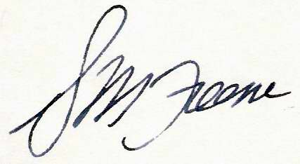
[TextInput{"system-name":"lender-signatory-name"}]
[TextInput{"system-name":"lender-signatory-title"}]
[Date{"system-name":"lender-signing-date"}]

Acknowledged and agreed to by:

By: ___________________________
[TextInput{"system-name":"guarantor-signatory-name"}]
[TextInput{"system-name":"guarantor-signatory-title"}]
[Date{"system-name":"guarantor-signing-date"}]
[TextInput{"system-name":"guarantor-telephone"}]

